Welcoming a New Season!
The WECRD board is currently in the process of evaluating the bids submitted for Construction Manager Qualifications. Once a construction manager is selected, the focus will shift to obtaining project estimates and securing contractors. Although this marks the final phase of the Aquatic Center project, it may involve multiple sub-phases within the overall process.
The phases will encompass all essential components—interior walls and ceilings, plumbing, electrical systems, showers, sinks, toilets, and every other element required to make the facility fully functional.
The Recreation Foundation remains actively involved in advancing the Aquatic Center, both by promoting the project and pursuing additional funding through grants and donations. They also continue to lead guided tours, giving residents an up-close view of the progress.
As always, please direct any questions to office@wecrd.org, and we will do our best to provide an answer. You are also welcome to attend our monthly board meeting, held every Wednesday at 6 PM. Dates and times are published on our website and Facebook.
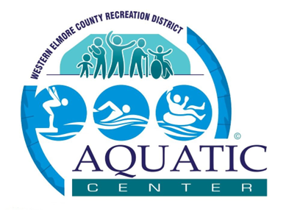
For more information, please visit our website at www.wecrd.org.

Western Elmore County Recreation District
245 E. 6th S., Mountain Home, ID 83647
208-580-2377
www.wecrd.org

